- Best steady state is the one which maximises consumption per capita
C* = (1-s) f(k*)
- Increase in s raises k* therefore y*, which allows c* to raise. However it may also reduce consumption’s share of income, which may lower c*. The level of k* and s that maximise c give us the golden rule steady state
C* = Y* - i*
C* = f(k*) – i*
C* = f(k*) – (depreciation + n)k*
- Steady state is where the investment rate equals the depreciation rate, thus the capital stock remains constant and growth is zero
Y = c + I
Want to maximmise c
- Golden rule is the level of capital that maximises the difference between output per person and investment per person i.e. space between alphak and output.
- Need to discover the optimum labour/capital ratio
Golden rule steady state
Investment = savings times output
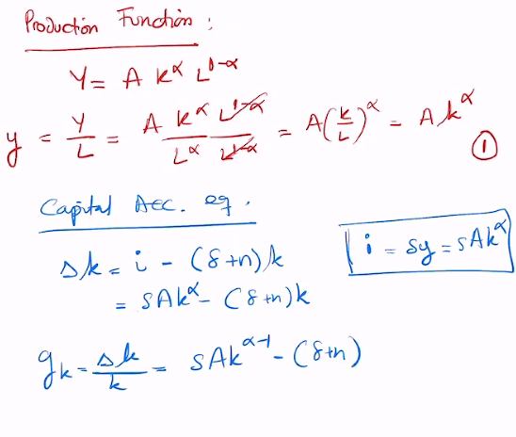
Alpha is between 0 and 1. Alpha minus 1 is negative
Growth rate of capital falls and K rises
Steady state is level at which growth of capital is equal to 0

Differences in A are the issue. A can be due to technological progress, population, institutions.
Conditional toward your own steady state
A is very important
Is R&D profitable? Doesn’t make sense in Solow
Profit = production minus Wl - rK
W = MPL and r = MPR
Due to CRS, thus competitive markets

- Endogenous growth models try to explain A
- Y hat is total output divided by labour force and technology. Output per effective labour unit. Relevant when A is growing.

Relationship between savings rate
- Level of capital stock that maximises consumption
- Rule is MPK equal to deprecation plus population growth
C* = y* - i*
Y = AK^ alpha
Investment is (delta + n)K
C* = AK^alpha – (delta + n)k^alpha
Differentiate wrt alpha
AK^alpha – 1 = (delta + n)
Savings rate needed to reach the golden rule (where MPK) needs to be where all income from renting capital goes back into savings (s = alpha)
Alpha is one third in the UK
Alpha is country specific – based on share of capital in the country

- Conditional convergence
Countries with similar savings rate, institutions, depreciation rates, populations, education levels will converge, meaning countries with lower initial GDP per capita will grow more quickly.
Diminishing returns to capital

- Assume that technological progress is labour augmenting

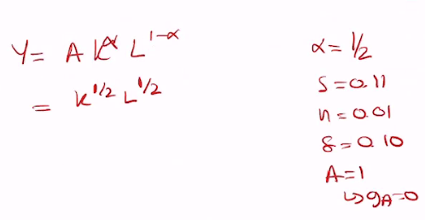

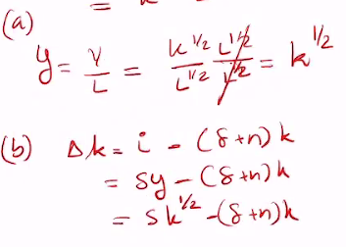0.11k^1/2 – (0.11)k
c) k* = ?
Set delta k to O
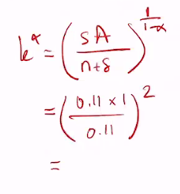
Output in steady state is also 1
Whats the golden rule level? MPK = delta + n
Delta + n = 11%
Alpha > savings rate so not at golden rule
Differentiate output wrt K
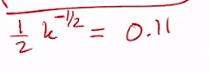
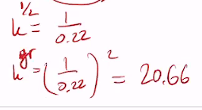
Doubling the savings rate from 0.11 to 0.22 (still below 0.5 golden rule)
K* = (SA/ n + delta)^2
K* = 4 x old k
Old capital stock was 1, now its 4
Output is now 2


Consumption must dip initially. But then future generations will be better off with higher consumption
Increasing the savings rate makes everyone better off in the long run (couple of decades)
How does depreciation work in service industry?

- Initially at its steady state. Y = AK^$α$L^1-$α$
  - Poorer population health and reduced fertility. A will fall (less efficient) and so will n (fertility – population growth). Capital per capita may increase or decrease depending on relative changes
  - Investment should increase. Capital stock should grow. Capital per capita increases therefore so does output per capita. By how much depends on initial level. Level of output in the economy should raise.
  - Capital stock falls and so does labour. Capital per capita may stay the same, but total output definitely falls.
  - New tech increases productivity and durability of capital. A goes up and delta goes down. New steady state is higher
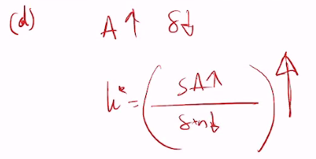

For the assessment you don’t use equations, you can use words and graphs. Maybe evidence from real world

